* **@MappedSuperclass**

Parent class không phải là table trong database

VD1:

|  |  |
| --- | --- |
| https://3.bp.blogspot.com/-1FxpbAmKozM/W_1Gjw2ITVI/AAAAAAAAFAo/Bvlv964rxzkIUWp-poubO2WWf0qFJtvDACLcBGAs/s1600/inheritance_class_diagram.jpg  *Java* | *SQL* |

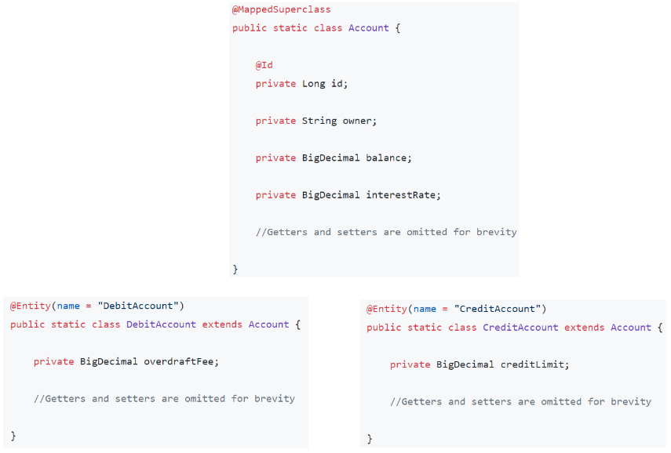

*Parent class (Account không phải là 1 table trong database nên không có @Entity)*

* **Reference**

https://www.javaguides.net/2018/11/hibernate-jpa-mappedsuperclass-inheritance-example.html?m=1&fbclid=IwAR1bw-Pl5A6WW0tPnDNq6ItuwU3M-f_7034o8i6iBJ10PMJRkAiYMe9O9Ko

<https://www.baeldung.com/hibernate-inheritance>